Diagnosing Hardware FailuresTheory
1.List 5 common hardware issues you might encounter in a desktop PC and write the typical symptom for each (for example: 'No display on monitor' — symptom: blank screen, no POST beep).
Computer Hardware Troubleshooting Practical Assignment
1. Five common hardware issues in a desktop PC and their symptoms
A hardware issue occurs when a physical computer component is damaged, disconnected, overheating, or not functioning correctly. Identifying symptoms helps a technician find the possible cause and select the correct troubleshooting method.
No. | Hardware issue | Typical symptoms | Possible cause
1 | No display on the monitor | The monitor shows a blank screen or “No Signal”; the PC may power on but display nothing. | Loose display cable, faulty GPU, RAM issue, or monitor problem.
2 | RAM failure | The PC may fail to POST, restart repeatedly, freeze, or produce memory-related beep codes. | Faulty RAM module, improperly seated RAM, or incompatible memory.
3 | Power supply (SMPS) failure | The computer does not turn on, shuts down unexpectedly, or restarts under load. | Faulty SMPS, loose power cable, or unstable power delivery.
4 | CPU overheating | The PC becomes unusually hot, the fan runs loudly, performance drops, or the system shuts down. | Dust buildup, failed CPU fan, poor heatsink contact, or dried thermal paste.
5 | Hard disk or SSD failure | The computer boots slowly, files become inaccessible, the system freezes, or an operating-system boot error appears. | Drive failure, loose SATA/power cable, or a damaged storage connection.
Explanation of the five issues
- No display: Check that the monitor is powered on and connected to the correct video output. If necessary, check RAM seating and the graphics card.
- RAM failure: Turn off and unplug the computer before reseating the RAM. Test one compatible module at a time if appropriate.
- SMPS failure: Check the power cable and outlet first. A technician can test the PSU's output voltages using suitable procedures.
- CPU overheating: Check that the cooling fan operates and that air vents are clear. Switch off the PC if it overheats repeatedly.
- Storage failure: Check whether the drive's power and data cables are secure. Back up important data if the drive is still accessible.
Conclusion: Symptoms help identify a possible hardware fault, but a symptom alone does not prove that a particular component has failed. Proper testing is needed to confirm the cause.
2. Step-by-step troubleshooting plan for a laptop that is not charging
Scenario: The laptop is connected to its charger, but the battery percentage does not increase, or the laptop does not turn on.
The following procedure uses basic tools and visual inspection only, without software diagnostics.
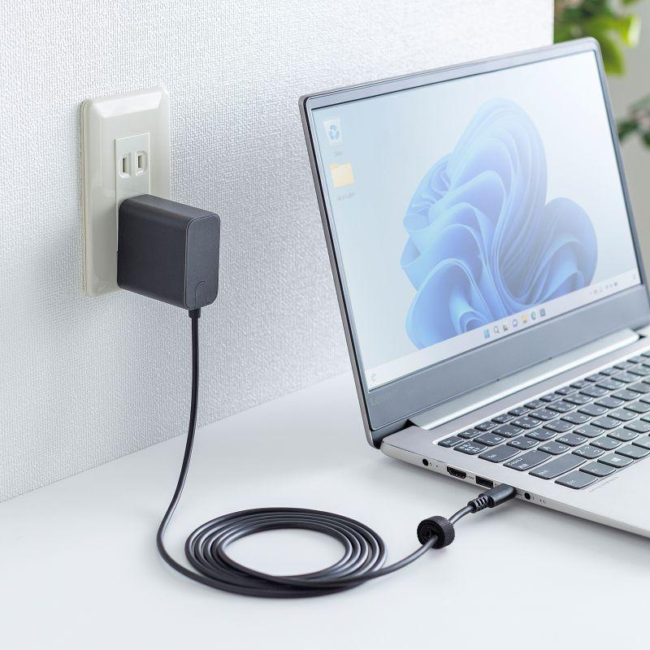
Step 1: Check the wall outlet
- Make sure the outlet has power.
- Test it with a known-working, suitable device.
- Check the wall switch or power strip if one is used.
What this checks: Whether the electrical supply is reaching the charger.
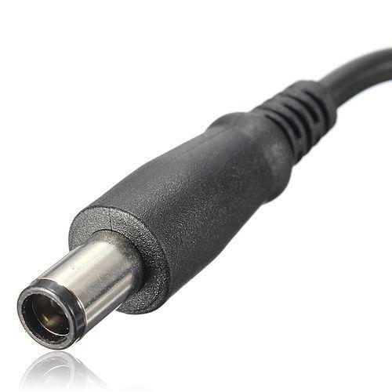
Step 2: Inspect the charger and cable
- Look for cuts, exposed wires, bent connectors, or burn marks.
- Check that the adapter and laptop connector fit properly.
- If the cable is damaged or smells burnt, stop using it.
What this checks: Whether a visibly damaged charger or cable could be preventing power delivery.
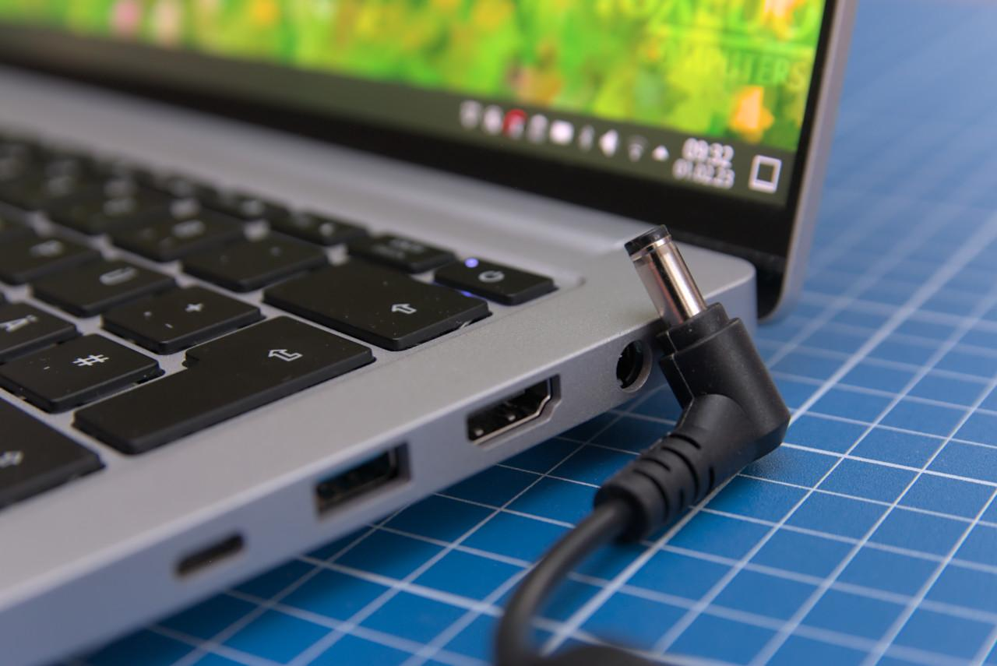
Step 3: Inspect the laptop charging port
- Disconnect the charger.
- Look for dust, debris, a loose port, or bent contacts.
- Do not insert metal objects or force the connector.
What this checks: Whether a damaged or obstructed charging port may be preventing a good connection.
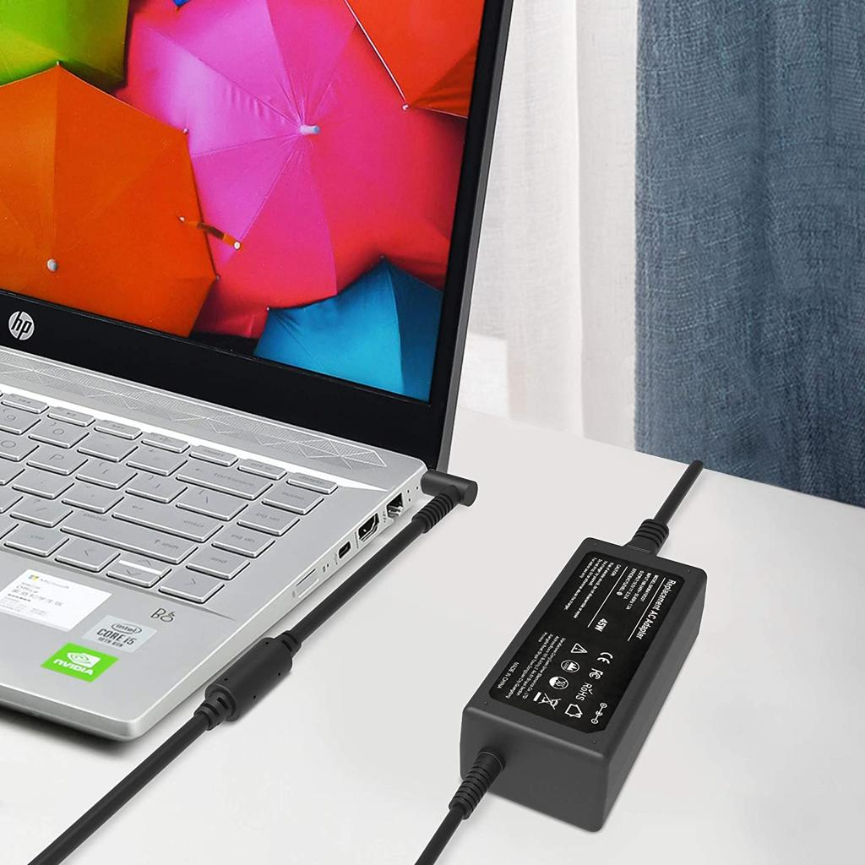
Step 4: Test with a known-working compatible charger
- Use a charger approved for the exact laptop model.
- Match the required voltage, connector and power rating.
- For USB-C charging, ensure the adapter and cable support the required USB Power Delivery wattage.
What this checks: Whether the original charger or cable is faulty.
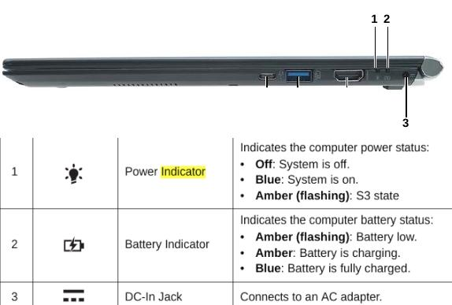
Step 5: Observe the charging indicator
- Connect the compatible charger.
- Check whether the charging LED turns on, blinks, or remains off.
- If the laptop starts, check whether its charging indicator shows that power is connected.
What this checks: Whether the laptop appears to recognize the charger. An LED alone does not confirm that the battery is charging correctly.
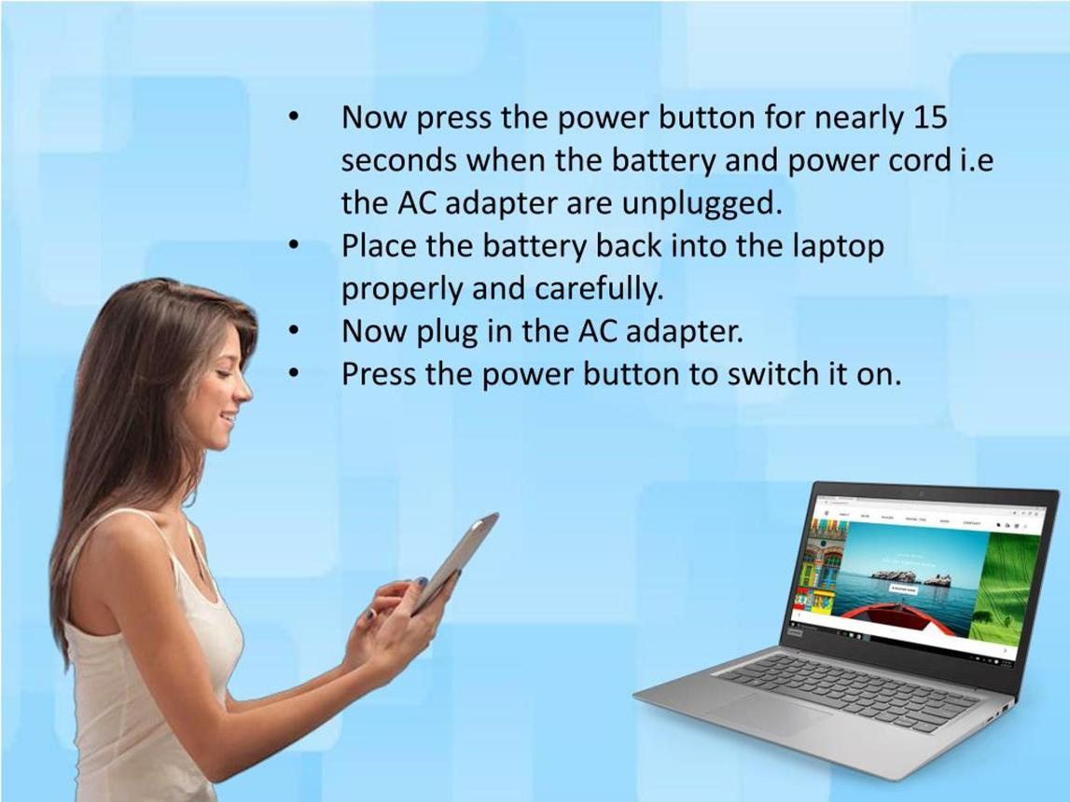
Step 6: Perform a safe power reset
- Disconnect the charger and external accessories.
- If the battery is removable, remove it only according to the manufacturer's instructions.
- Hold the power button for about 15–20 seconds, then reconnect the charger and try starting the laptop.
- Do not open the laptop or disconnect an internal battery unless you are qualified and the service instructions permit it.
What this checks: Whether a temporary power-controller state is preventing normal startup or charging.
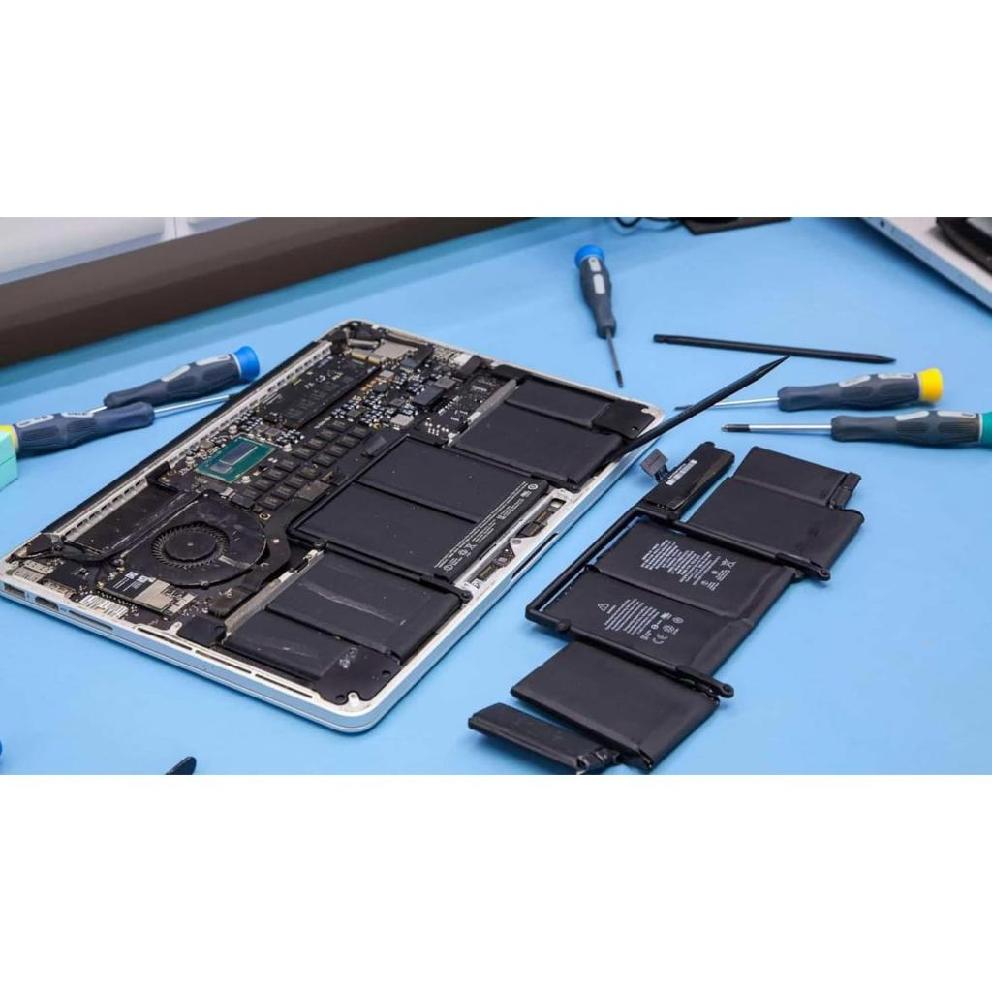
Step 7: Consider the battery and internal charging circuit
- If a removable battery is present, inspect it for swelling, leakage, or damage.
- Do not use a swollen or damaged battery.
- If a known-working compatible charger does not help, the battery, DC jack, charging circuit, or motherboard may require professional testing.
What this checks: Whether the fault may be inside the laptop rather than in the external power supply.
Troubleshooting decision table
Observation | Possible explanation | Next action
No charging light and no power | Outlet, charger, port, or motherboard fault | Check outlet and compatible charger.
Laptop works on AC power but battery does not charge | Battery or charging circuit issue | Test with approved service procedures.
Charging light blinks unusually | Model-specific charging or battery fault | Check the manufacturer's manual.
Laptop charges with another compatible adapter | Original adapter or cable fault | Replace the faulty part with an approved equivalent.
Port is loose, hot, or visibly damaged | Charging connector or board fault | Stop using it and arrange repair.
Conclusion: Start with the outlet, charger, cable and port before suspecting the battery or motherboard. These checks can identify common causes without diagnostic software.
3. Testing the voltage output of a standard USB phone charger using a multimeter
Aim
To measure the output voltage of a standard 5 V USB phone charger using a digital multimeter and determine whether the reading falls within the expected range of 4.75 V to 5.25 V.
Required materials
- A digital multimeter.
- A standard USB phone charger.
- A compatible USB breakout adapter or USB test board with accessible power and ground contacts.
- A USB cable, if required.
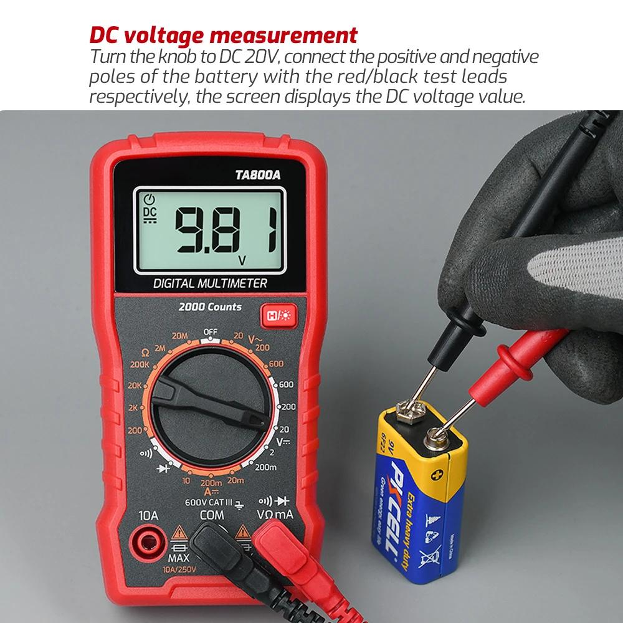
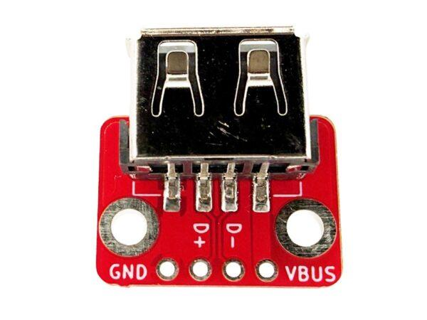
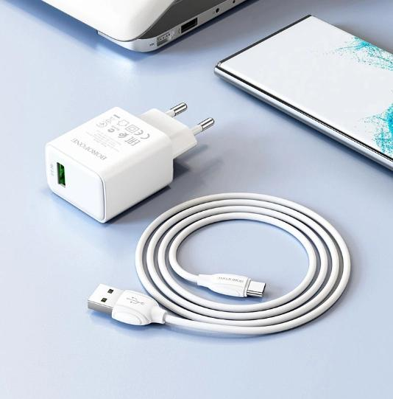
Step-by-step procedure
- Inspect the charger. Check the adapter and cable for visible damage. Do not use a damaged, wet, or burnt-smelling charger.
- Prepare the multimeter. Insert the black lead into the COM socket and the red lead into the V or VΩ socket.
- Select DC voltage. Set the dial to DC voltage (V⎓). Choose a range above 5 V if your meter is not autoranging; for example, the 20 V DC range.
- Connect the USB breakout adapter. Connect the charger to a suitable wall outlet and the breakout adapter. Keep the charger's mains side enclosed and untouched.
- Measure the voltage. Place the red probe on the USB VBUS (+5 V) contact and the black probe on GND (ground). Use an accessible breakout board rather than trying to insert loose probes into a USB socket.
- Record the reading. Wait for the display to stabilize and write down the measured voltage in volts (V). Avoid letting the probes touch each other or bridge adjacent contacts.
- Compare the result. A reading from 4.75 V to 5.25 V is within the expected range specified for this exercise.
Observation table
Test detail | Result
Expected voltage | 5.00 V nominal
Acceptable range for this assignment | 4.75 V–5.25 V
Actual measured voltage | Enter your multimeter reading
Result | Within range / Outside range
Example calculation and result
Suppose the multimeter displays 5.08 V. This is an example reading, not a measurement from your charger.
- Lower limit: 4.75 V
- Example measured voltage: 5.08 V
- Upper limit: 5.25 V
Since $4.75≤5.08≤5.25$, the example result is within the expected range.
If the reading is outside the range, check the meter setup, connections and charger specifications before concluding that the charger is defective. Some chargers use different output modes, and voltage measured without a load does not establish that the charger works properly under load.
Result and conclusion
The output voltage of the USB charger is measured using a digital multimeter set to DC voltage. The measured value is compared with the expected range of 4.75 V to 5.25 V. The charger meets this voltage criterion if the actual reading lies within that range.
Safety: Never open a phone charger or touch its mains-side circuitry. If you do not have a USB breakout adapter or are unfamiliar with multimeter probes, use a USB voltage tester instead.
4. Troubleshooting a PC that randomly shuts down by testing the SMPS 12 V rail
Aim
To check the 12 V output rail of a desktop computer's SMPS (Switched-Mode Power Supply) using a digital multimeter and determine whether the voltage may be contributing to unexpected shutdowns.
Why test the 12 V rail?
The 12 V rail supplies power to components such as the CPU voltage-regulator circuitry, graphics card and certain drives or fans. If its output is outside the permitted range, it may indicate a power-delivery problem.
- Yellow wire: +12 V
- Black wire: Ground (0 V)
- Expected nominal voltage: 12 V DC
- Typical ATX tolerance: ±5%, or approximately 11.40 V to 12.60 V
Required materials
- Digital multimeter with insulated probes.
- Desktop PC ATX power supply.
- Compatible ATX connector or suitable PSU test adapter.
- PSU tester, if available.
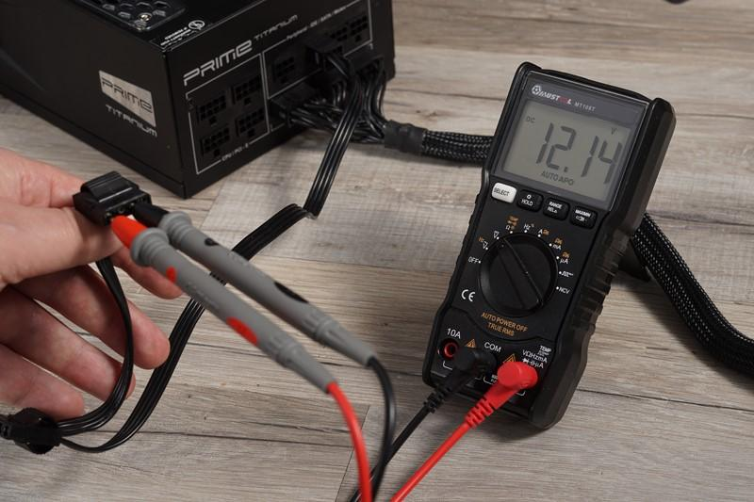
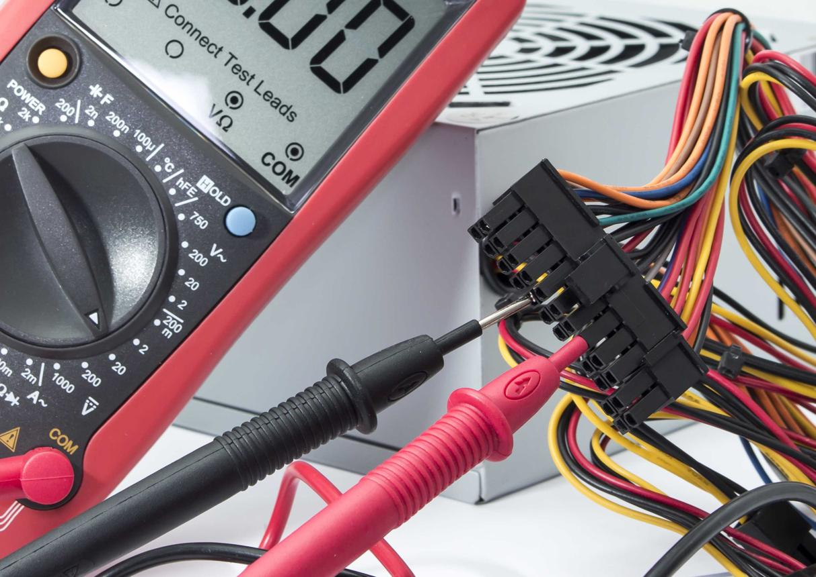
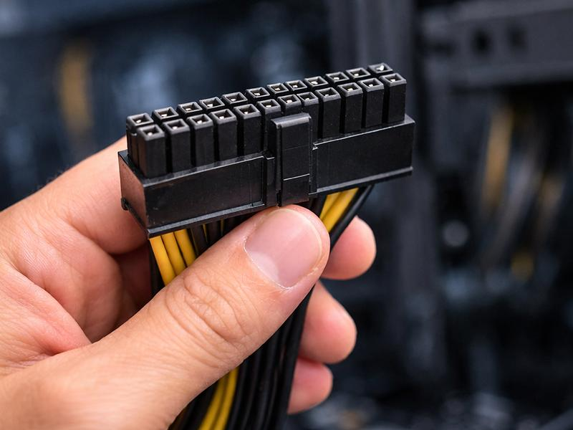
5
Safety warning
Testing an energized ATX power supply involves exposed electrical contacts. Do not open the PSU casing or attempt live testing if you are a beginner. Use a commercial PSU tester or ask a qualified technician to perform this practical. The procedure below describes the test concept and the precautions involved.
Step-by-step procedure
- Switch off and disconnect the PC. Turn off the power supply and unplug its AC power cable before handling any connector.
- Identify the ATX connector. Locate the 24-pin motherboard power connector and identify the yellow (+12 V) and black (ground) wires using the PSU pinout documentation. Wire colors are common conventions, so verify the connector before testing.
- Isolate the connector from the motherboard. With the AC power disconnected, disconnect the ATX connector from the motherboard. Never remove or reconnect it while the system is energized.
- Prepare the multimeter. Put the black lead in COM, the red lead in V, and select DC voltage (V⎓) on an appropriate range above 12 V, such as 20 V on a manual-ranging meter.
- Energize the PSU only using a suitable test setup. A PSU tester or a technician-approved test fixture can enable and load the PSU safely. Do not improvise with loose jumpers or exposed probes if you are inexperienced.
- Measure between +12 V and ground. Using the appropriate protected test points, connect the red probe to the yellow +12 V output and the black probe to a black ground output. Prevent probe tips from touching adjacent contacts.
- Record the reading. Note the actual voltage shown by the multimeter. If possible, a technician should also check the voltage under an appropriate load because a supply may appear normal without one.
- Power down safely. Switch off and unplug the PSU before removing test equipment or reconnecting the motherboard connector.
Observation table
Test detail | Value
Rail tested | +12 V DC
Positive test point | Yellow wire
Ground test point | Black wire
Nominal voltage | 12.00 V
Typical acceptable range | 11.40 V–12.60 V
Actual measured voltage | Enter your actual reading
Example result
Suppose a technician measures 11.30 V. This is an example only, not an actual measurement of your PC.
- Expected nominal voltage: 12.00 V
- Example measured voltage: 11.30 V
- Lower typical tolerance limit: 11.40 V
Since 11.30 V is below 11.40 V, the example reading is outside the typical ATX tolerance.
If the voltage is below 11.5 V, what could it indicate?
A reading below 11.5 V may indicate:
- A faulty or aging SMPS that cannot maintain its output voltage.
- An overloaded power supply, particularly if a high-power GPU or CPU is installed.
- A poor electrical connection at a connector or cable.
- A measurement issue, such as incorrect probe contact or an unsuitable meter setup.
A low 12 V reading can be associated with random shutdowns, but it does not prove that the SMPS is the cause. The voltage should be rechecked using a suitable test setup, ideally under load, and other possible faults should also be considered.
Conclusion
A multimeter can help assess the SMPS 12 V rail by measuring between the yellow +12 V wire and a black ground wire. A typical ATX supply should maintain approximately 11.40 V to 12.60 V under the specified test conditions. A reading below 11.5 V deserves further investigation, and a reading below 11.40 V is outside the usual ±5% tolerance. A qualified technician should confirm the result before replacing any component.
Final assignment submission checklist
Question 1: Five hardware issues and their symptoms written.
Question 2: Laptop charging troubleshooting steps written.
Question 3: Actual USB charger voltage measured and recorded.
Question 4: Actual or technician-measured 12 V rail reading recorded.
0 of 4 assignment sections completed
Remember to replace the example readings with your actual measurements. If you cannot perform the electrical tests safely, state that the readings are pending rather than reporting example values as real results.

